Quang Nguyen

CPE 409 Lab

# Goals

# Equipment used

# Design Specifications

# Design

# Verification

### Part 1

Result of 255 * 255 = 65025

Result of Timer 1 with a prescaler of 1 was 2833

0.0625 us * 2833 = 177.06 us or 0.17706 ms



### Part 2

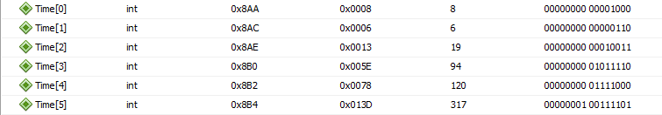

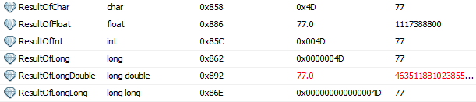

### Part 2 with division

Op1 = 85, Op2 = 14

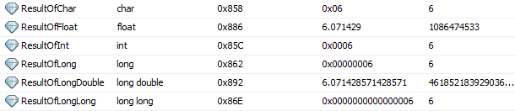

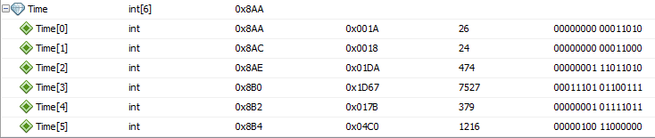

Part 3.

Q16.16 multiplication



Q15.16 Addition



Float addition



# Questions

# Conclusions and Limitations